**Computer Networks**

**Lab Number 10**

Name: Ahmed Kasteer

Section: 5C

Roll Number: 20F-0336

**Task No.1**

Open a web browser installed in your computer. Type[**www.google.com.pk**](http://www.google.com.pk) inside the address bar. Now locate the HTTP request message sent by your browser to retrieve the home page of [**www.google.com.pk**](http://www.google.com.pk)**.** While looking at very first frame message for http packet, answer the following questions

**Google doesn’t follow http. it follows quic protocol,**

|  |  |
| --- | --- |
| **Part I** | |
| 1 | Is the frame an outgoing or an incoming frame? |
| 2 | Source IP address of the network-layer header in the frame: |
| 3 | Destination IP address of the network-layer header in the frame: |
| 4 | Total number of bytes in the whole frame: |
| 5 | Number of bytes in the IP header: |
| 6 | Number of bytes in the TCP header: |
| 7 | Total bytes in the message (at the application layer): |

**Part B**

Open a web browser installed in your computer. Type[**www.google.com.pk**](http://www.google.com.pk) inside the address bar. Now locate the HTTP request message sent by your browser in order to retrieve the home page of [**www.google.com.pk**](http://www.google.com.pk)**.** While looking at that message, answer the following questions.

* What languages the browser can support?
* What is the type of browser that has sent this HTTP request message?
* What type of HTTP connection the browser has requested?
* What URL is requested by the browser from the server?
* Now download two images using your browser. Can you tell whether your browser downloaded the two images serially, or whether they were downloaded from the two web sites in parallel? Explain

Now identify the HTTP response message sent for HTTP request message and answer the following questions.

* What is the status code sent by server?
* What is the response phrase sent along with status code?
* What host had you requested and what host has been accessed?
* Has the server sent a cookie ID in response message? If yes, what is the cookie ID and when does it expire according to Pakistan Standard Time?
* What is type of content that the sent page contains?

As the google doesn’t follow http protocol ,the following questions can’t be answered

Now type [**slate.nu.edu.pk**](http://www.network-tools.com) in the address bar and locate HTTP request message sent by your browser to the server. Now answer the following questions from this HTTP request message.



* What is the version of browser which sent this request message?

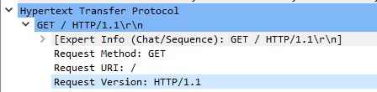

* What type of connection the browser has requested?



* Which request method is used in the request message?



* How long did it take from when the HTTP GET message was sent until the HTTP OK reply was received? (By default, the value of the Time column in the packet listing window is the amount of time, in seconds, since Wire-shark tracing began. To display the Time field in time-of-day format, select the Wire-shark View pull down menu, then select Time Display Format, then select Time-of-day.)

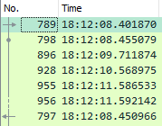

Now locate the HTTP response message received for this HTTP request message and answer the following questions.

RESPONSE MESSAGE



* What is the status code and response phrase sent by server for this request?





* Has the server sent any cookie ID along with response message? If yes, what is the id and when will it expire?

No. server has not sent any cookie id along with the response message.

However, the client sent the cookie id in the request message.

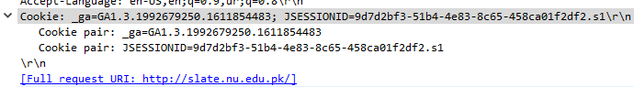

* What was the time at server when it sent the response message. Write down the time in PST.

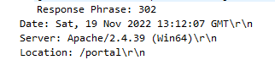

13:12:07 GMT 🡪 18:12:07 PST

………………………………………………………………………………………………………………………………………………………………………………

If the response message contains status code 301 then the browser will send another HTTP request message automatically without user’s intervention. Now locate that HTTP request message inside the Wireshark and answer the following questions.

* What HTTP method is used in the request message?
* What type of connection the browser has requested from the server?
* What is the value of Host header field?
* Do you see any difference between the host name sent in this request message and the host name that you had requested actually when you typed it in address field in browser? If yes, what difference you see?

Now locate the HTTP response message sent for this HTTP request message and answer the following questions.

* What is the status code and response phrase sent by server in response message?
* What is the name of server?
* What type of contents the server has sent in response message?

ANSWER

the status code is not 301, the browser will not send another http request message.